New Power Supply Specification

Executive Summary
As a result of conducted and radiated noise from the original brick-based Power Supply Card (PSC) several alternatives were considered for powering the Multi-Channel Electronics (MCE). After considering all factors including weight and heat dissipation requirements, we decided upon the Split AC-DC and DC-DC Conversion based on ATX-PS. This solution allows for flexible grounding and noise isolation, results in low weight and heat dissipation at the MCE, and maintains the current topology while reducing the size and weight of the feed cables.

References
[1] Alternatives to Brick-based PSC analysis, http://www.physics.ubc.ca/~scuba2/sc2mce/system/psu-300Vin/design/docs/Alternatives_to_Brick-based_PSC_2005-04-19.doc

Overview
The new MCE power supply follows the existing topology, but replaces the 24VDC supply with an AC to DC Conversion Unit (ACDCCU) and the PSC with a shielded, synchronous-switching Power Supply Unit (PSU). Figure 1 illustrates the new design.
Figure 1. New MCE Power Supply Overview
The PSU’s low primary current, shielding and filtering will assure low conducted and radiated noise. The two levels of isolation (at PSU and ACDCCU) provide flexibility in grounding scheme implementation. A remote control interface is provided for maximum flexibility in power control. A 20mA safety loop with discharge circuitry guards against accidental arcing of and/or contact with the floating 300V DC feed. At the request of JAC we have added a low-power safety switch to the front panel of the PSU to be able to manually break the 20mA safety loop prior to its removal from the sub-rack as required by JCMT’s operations and maintenance procedures.
The space allocation for the PSU and mechanical outline of ACDCCU are shown in Figure 2 and Figure 3 respectively. Figure 4 shows how the 8 ACDCCUs are mounted on the 19” rack. These drawing are representative of the design intent, but don’t necessarily reflect the detailed final design.

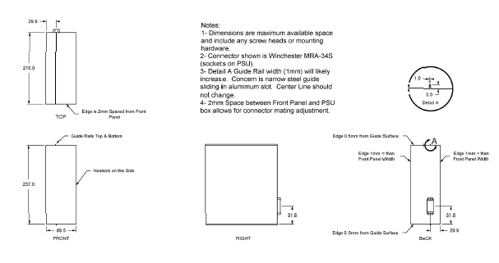
Figure 2. PSU Front Panel and Space Allocation

Figure 3. ACDCCU Outline Views
Figure 4. ACDCCU 19” rack-mounting front view

Detailed MCE Powering Diagram
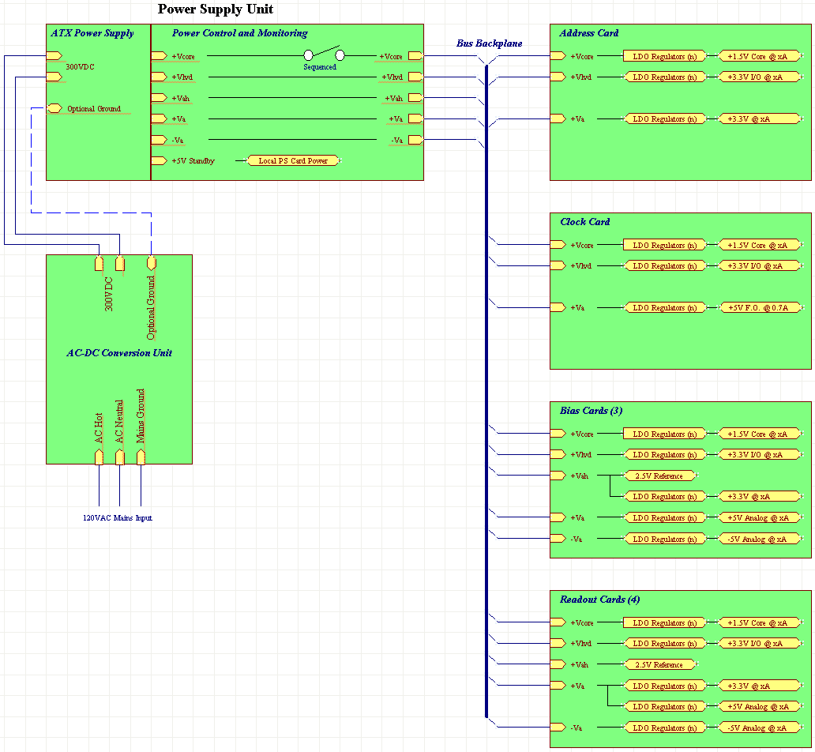
Figure 5. MCE Powering diagram with one subrack detailed

As it can be seen from the detailed MCE Powering diagram (Fig.5), the PSU output voltages are further regulated down by onboard linear regulators to the levels, which are required by the individual components on the same modules. It provides four advantages:
- There is no feedback between the various modules through the powering scheme.
- The voltage sources are as close to the components as possible, thus minimizing the feedback within the module through the power supplies.
- The power dissipation is more evenly distributed across the sub-rack.
- Short circuit on one module is isolated from the rest of the modules even without onboard fuses.

Specifications

PSU

Input:
Voltage: 270 to 300 V DC floating (depends on AC input and PSU load)
Current: 0.8 A maximum.
Ripple: 4V PP maximum @ 120 Hz.

Expected power consumption by MCE (PSU total output power)
Tbd. but ~ 170W.

Outputs:
- +Vcore: +2.5 to +3.0V at 13A, regulated by each card to +1.5V for powering the FPGA core
Ripple: RMS tbd but < 100μV p-p tbd but < 7mV
- +Vlvd: +4.5 to +5.0V at 4A, regulated by each card to +3.3V for powering the logic and FPGA I/O
Ripple: RMS tbd but < 100μV p-p tbd but < 6mV
- +Va: +6.2 to + 7.0V at 15A continuous, regulated by each card to +5.0V for the analogue circuitry;
also provides +5.0V for Clock Card’s Fibre-Optic and Subrack Synchronisation circuitry
(18A for 1 min max. during power up voltage dropping to 6.05V)
Ripple: RMS tbd but < 100μV p-p tbd but < 6mV
- -Va: -6.2 to –7.0V at 2A, regulated by each card to –5.0V for the analogue circuitry
Ripple: RMS tbd but < 100μV p-p tbd but < 6mV
- +Vah: +10.0V at 150mA, used by each card to supply voltage reference generators
Ripple: RMS tbd but < 100μV p-p tbd but < 5mV

Controls:
The PSU has an inherent analogue feedback system, which controls all the outputs. In case of over-current it automatically shuts down all the outputs. The PSU can only be recovered from this state by cycling the DC on/off function (either locally or remotely) provided by the ACDCCU with a > 15 second pause in the off condition. The overload shutdown has a short (< 15 second) memory once DC is turned off otherwise it remains permanently latched shutdown.
This function can also be accomplished by cycling the AC master switch on the ACDCCU or any other means of powering down the AC input to the ACDCCU, provided the off condition pause is > 15 seconds.
The PSU also has an on-board microprocessor, which performs limited diagnostics testing of its own. It monitors if the output voltages are within the operating range and performs shut down if deemed necessary. It also communicates with the Clock Card. The latter monitors the PSU temperature and forwards this information to the operator who can initiate emergency reset or shutdown, using DRAMA commands.

Indicators:
Front panel located.
A. Power Connected, green LED, indicates DC input is present.
B. Power OK, green LED, indicates that all output voltages and current are within the operating range.
C. Power Off. Red LED is on when input DC is on, but all its outputs are shut down regardless of how it got into that state.

Connectors:
Front panel located; 9-pin AMP CPC Series 1 “quick lock” type connector for DC input,
includes safety loop leads

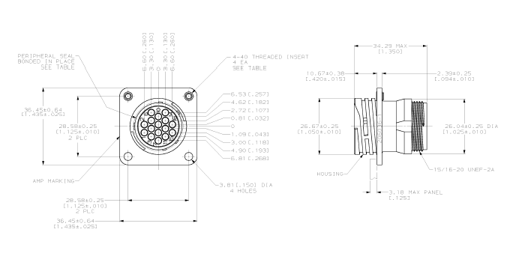

Rear panel located: 34-pin Winchester MRA series
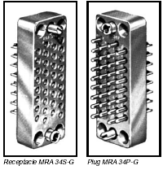

Connector pin-out
Will be defined during development.

Remote functions (see 3.1.3. Controls)

Isolation:
The floating 300VDC input is contained within magnetically shielded enclosure. It is isolated from the regulated output circuits by DC-DC converter circuitry with isolation transformers with 1.5KV AC tested HI-POT capability.

Adjustments:
None.

Dimensions:
Length: 215 mm (8.25 in), not including mating connectors, cables and handles.
Width: 89 mm (3.75 in) maximum (includes heat-sink, mounted outside of the enclosure)
Height: 237 mm (9.25 in)

Weight:
tbd kg, not including connecting cables.

Internal Power Dissipation
Tbd, but < 35W. We are currently measuring 31W, including fan power.

Cooling:
Internally: fan cooled to avoid hot spots.
Externally: it is part of the MCE and will be air-cooled as any other modules within the sub-rack.
In order to improve external cooling efficiency the PSUs are equipped with full vertical fins, which together with the sub-rack side panel create chimney effect, this way maximizing PSU cooling.

Environmental:
Operating Temperature: 0 deg. C to + 40 deg. C (same as all other module inside MCE)
at sea level (1 bar atmospheric pressure).
For increased reliability operating temperature should be kept
below 30 deg. C at the summit (0.6 bar)
Storage/shipping Temperature: 30 deg. C to + 85 deg. C
Humidity: 0 to 80 %, none condensing, storage or operating.

Routine Maintenance:
Repair/ replacement: Built-in fans have limited lifecycle of ~ 18000 hrs. They have to be
replaced on a maintenance schedule tbd., but not more often than
once in 12 months.
On-site maintenance and repair is not recommended, complete unit
replacement is advised, if unit has failed.

ACDCCU

Input:
Voltage: 120 V AC 60 Hz nominal, 108V minimum, 128 V maximum
Frequency: 49 to 61 Hz.
Waveform: Sine only, max 10 % total distortion
Current: 1.75 A RMS, 3.5 A Peak, typical, 12 A max. inrush.

Note: The input can be changed to 240 V nominal by internal reconfiguration
(Voltage range and current scale appropriately, not the inrush).

Output:
Voltage: 270 to 300 V DC floating (depends on AC input and PSU load)
Current: 0.8 A maximum.
Ripple: 4V p-p maximum @ 120 Hz.

Discharge time
Less than 50msec for the floating 300V DC to drop below 30V DC after being commanded or forced to turn off.

Controls:
A. Master on/off switch, turns on all AC input, front panel* located.
B. On/off/remote switch, turns DC output on/off locally, or selects
remote control of DC output on/off function, front panel* located.

*Note: Position of controls to be finalized with ATC

Indicators:
Front panel* located.
A. AC Connected, amber LED, indicates AC input is present and master switch is on, but DC output is turned off.
B. AC/DC ON, green LED, indicates DC output is on and connected to PSU
(serves as "all is well" indicator for AC/DC converter)

Rear panel* located.
Red LED, on = local DC connector is not properly seated and locked.
(This condition turns off DC output and the AC/DC ON green LED on the front as well as and turns on the yellow AC Connected LED on the front)

* Note: Position of indicators to be finalized with ATC

Connectors:
Rear panel* located; A. AC input, IEC standard instrument connector.
B. DC output (includes connector safety loop leads).

* Note: Position of connectors to be finalized with ATC

Remote functions: (optional)
Input: 5 mA maximum, minimum voltage 3.0 V
Output: NPN transistor, current sink 5 mA maximum.
These connections incorporate internal optical isolation.

Isolation:
The DC supply and the control supply are both isolated from the power
network and show a capacitive impedance to the network of 3 Megohms
minimum at 60 Hz.

Adjustments:
None.

Dimensions:
Length: 381 mm (15 in), not including mating connectors, cables and handles.
Width: 105 mm (4.125 in) maximum. (subject to increase if possible )
Height; 216 (8.5 in)

Weight:
9 kg per unit, not including connecting cables. (subject to increase)

Internal Power Dissipation
Tbd. but < 45W. We expect it to be ~30W under normal conditions

Cooling:
Fan cooled, unit front and back airflow must not be restricted.
Air inlet and air filter are at the front of unit.

Environmental:
Operating Temperature: -10 deg. C to + 40 deg. C
Storage/shipping Temperature: 30 deg. C to + 85 deg. C
Humidity: 0 to 80 %, non condensing, storage or operating .

Routine Maintenance:
Input air filter replacement: 6-month cycle, maximum (subject to change)
Fan replacement: 2-year cycle, maximum (subject to change)
Repair/ replacement: on-site repair is not recommended, complete unit
replacement is advised if unit has failed.

Grounding and Isolation
As Figure 1 shows, the 120VAC mains supply is isolated from both the floating 300VDC feed and the 20mA safety loop. The PSU provides another level of isolation between the floating 300VDC and the subrack. Therefore, we can float the entire power feed chain to prevent stray (noise) currents from returning through our power system. We also have the option of deliberately joining the PSU and ACDCCU grounds to control EM field radiation.

Power Control
An optional optically isolated Remote Control Interface could be available at the ACDCCU should it be desirable for a supervisory processor, say a PLC, to monitor and control the 300VDC output. For now this interface control is not connected to the outside world and will only be used during development testing.
This interface is purely digital, providing one output signal to indicate whether the floating 300VDC is enabled, and one input to allow the floating 300VDC to be switched on or off. At this point the 120VAC mains supply to the ACDCCU will be remotely controlled using devices such as the WTI NPS-115 network power switch currently at use at JCMT.

Data Interface
The PSU contains an integral control and supervisory microprocessor to sequence and monitor its output voltages. Temperature at various internal locations is also monitored. These voltage and temperature data are available to the MCE’s Clock Card via a Data Interface as follows.

Command / Data Protocol between the Clock Card and the PSU
Will be defined during detailed development

Powering MCE

Connecting the PSUs to the MCE
The PSUs occupy the rightmost position inside each sub-rack. They are connected to the rest of the modules via 34-pin self-aligning Winchester MRA series connectors, which in turn are connected to the redesigned Bus Back-planes through 14-22 AGW gauge wires. (The pin-out of the connector will be finalized as the PSU design solidifies.)
The PSUs are fastened to the sub-rack by four M2.5 screws to ensure that the relatively heavy units are firmly seated and they don’t get accidentally removed by flipping the ejectors.
The PSUs will be connected to their respective ACDCCUs via 6-wire flexible 18 awg cables from BELDEN or ALPHA screened and 600V rated. Out of the 6 wires two will be used for providing the power, one for shielding and grounding and two for the 20mA control loop. The power wires must have their own shielding, be tightly twisted with 600V AC isolating capability. This cable is attached to the PSUs through 9-pin AMP (Circular Plastic Connector) CPC Series1 connector, located on their faceplate. (The pin-out of the connector will be finalized as the PSU design solidifies).

The circular connectors will be provided with a built-in micro-switch, which activates after the power circuit is closed or deactivates before it is opened. The micro-switch operates a 20mA supervisory circuit, which prevents any arching from occurring or 300V DC exposed to touching. The supervisory circuit is located in the ACDCCUs. There is also a low-volt toggle switch in series with the micro-switch, mounted on the PSU faceplate, which can be manually operated during stand-alone repair and maintenance or before removing the
PSU from the sub-rack.

Connecting ACDCCUs to the power outlet
The ACDCC Units are mounted on a standard 19” rack located ~ 10m from the cryostat on a platform near the control and observing room. The same rack holds the VME crate, which controls the cryostat and provides the DV signals for the MCE. It also houses the control electronics and power supplies for the FTS and polarimeter.
Two ACDCC units occupy one shelf. Since the MCE consists of 8 subracks, eight ACDCCUs are required using up four min. 4.75” high shelves.
The ACDCCUs are connected to the 120V AC power through a remotely controlled power distribution system. They have standard EMI filters built in together with the 120V AC receptacle located at the rear of the unit. The power must have less than 10% distortion for the isolating transformers to operate with minimal heat loss. Even with minimal distortion the ACDCCUs dissipate max 45 W per unit. Under normal operating conditions the power dissipation is not expected to exceed 30W per unit. For proper cooling the units have built-in fans and filters, recommended by JAC. A built-in control circuitry is monitoring the internal temperature of the units and shuts them down if overheating occurs.

Overheating may occur in two cases: a) the air-filter is clogged b) the fan doesn’t run at nominal speed.
Turning power back must be preceded by checking the filter and the fan for their proper condition. This will be described later either in this document or a maintenance manual.

Status Indicators
Both the PSUs and ACDCCUs have indicator lights on their faceplates to reflect their status. See Figure 2, Figure 3, and Figure 4.

The Power Connected LED on the PSU is self-explanatory. The green Power OK LED is on when all DC outputs are within their operational range. When the red Power Off LED is on, then at least one output was outside of its specified range and consequently all outputs have been shut down. The PSU can get into this state either through internal control or by external command. The PSU’s microprocessor is still powered to ensure controlled power up sequence once it is initiated.

The ACDCCUs have several indicator lamps. The amber AC Connected LED is self-explanatory. When it is ON, the unit is connected to a live 120V AC outlet, the main switch is turned on, but the DC output is turned off. The AC/DC ON LED is green, when there is electrical connection between the ACDCCU and its PSU, regardless of the latter’s status. If however the cable between the ACDCCU and the PSU is disconnected, this indicator turns off and a red LED on the rear panel turns on. The cable connections are designed in such a safe way that none of the contacts, carrying floating 300V DC are live in this case.

